EDGE INTELLIGENCE
ASSIGNMENT NO: 2

DONE BY
DHAYANIDHI R S
[25MML0025]
Task-1:
Key Take aways:
- Analysing an image dataset-MNIST and applying basic preprocessing operations,
- Applied Artificial neural network on the following dataset.
- Saving the model using pickle model.

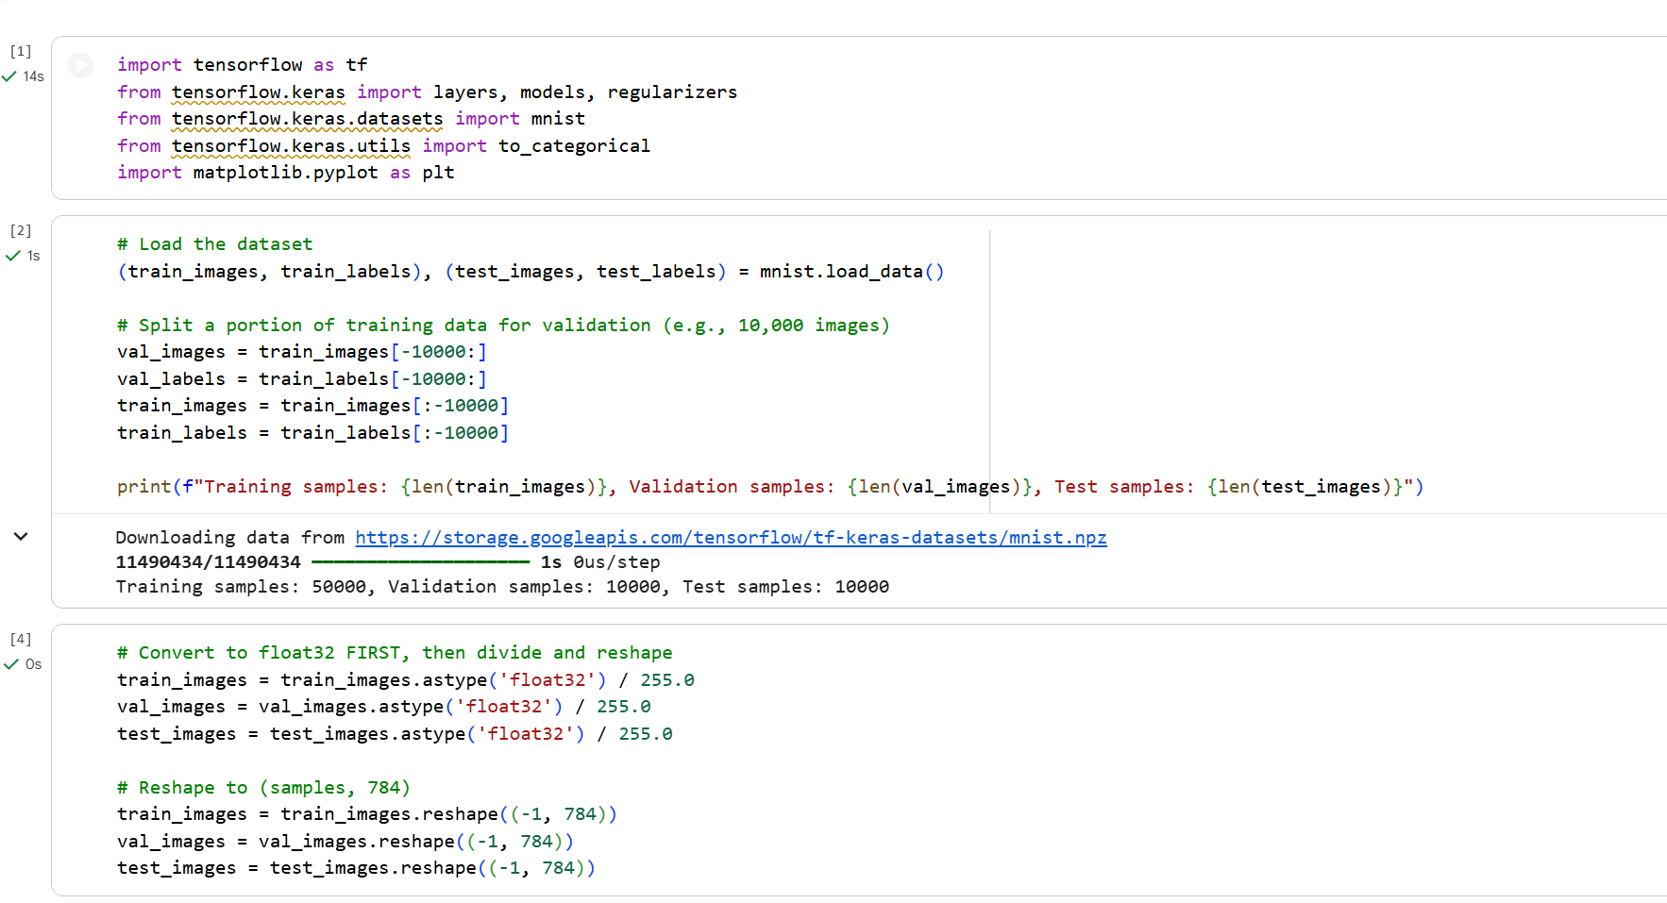
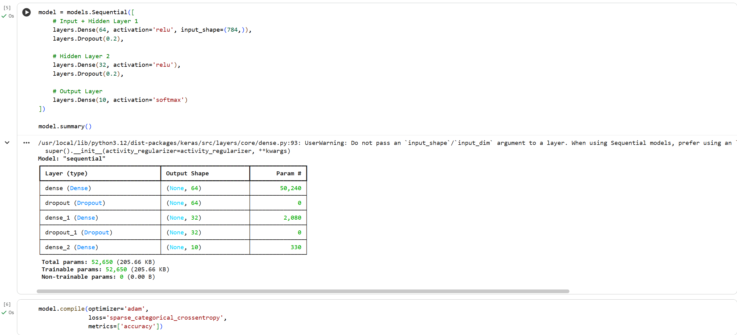

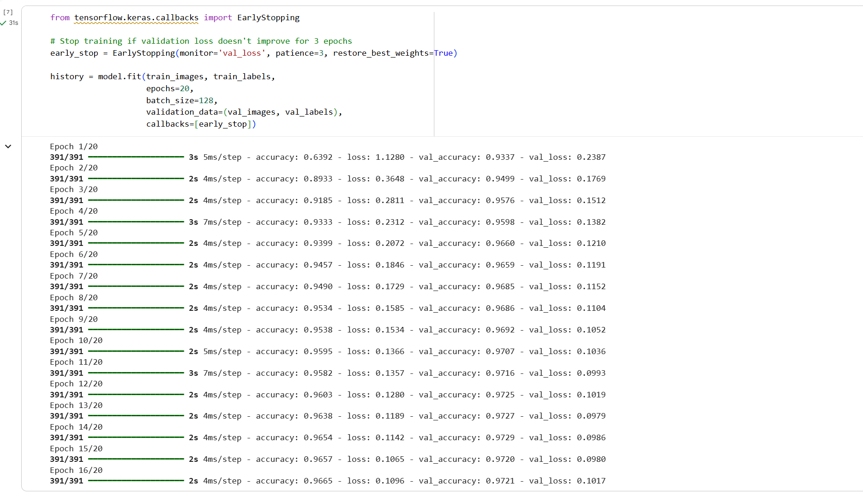
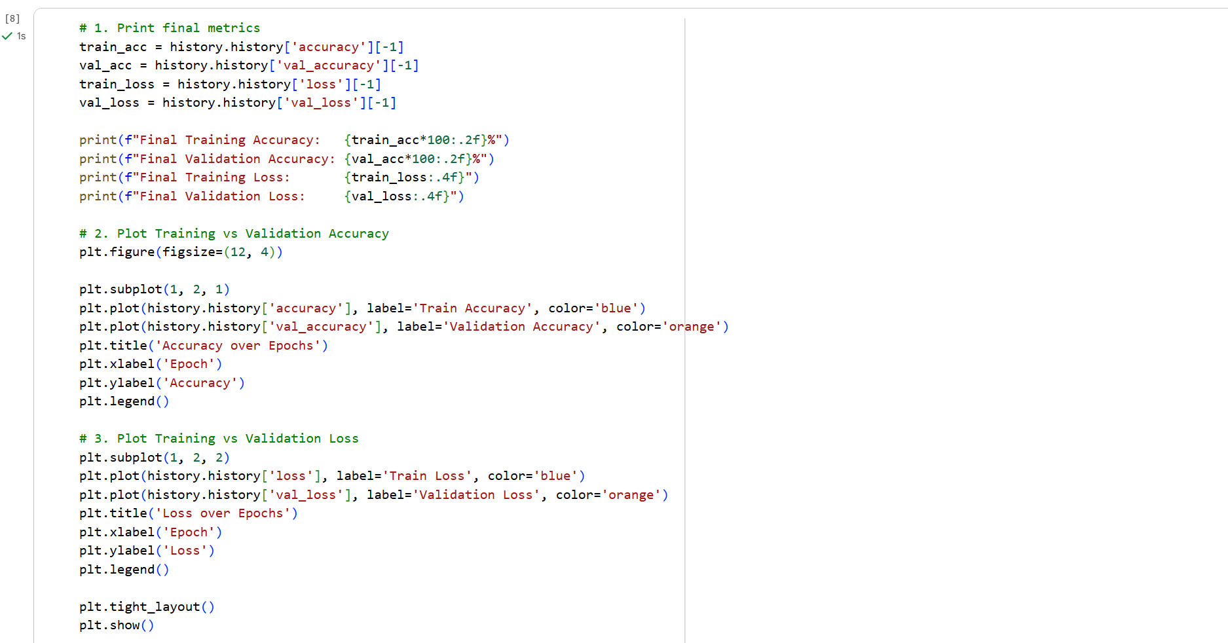
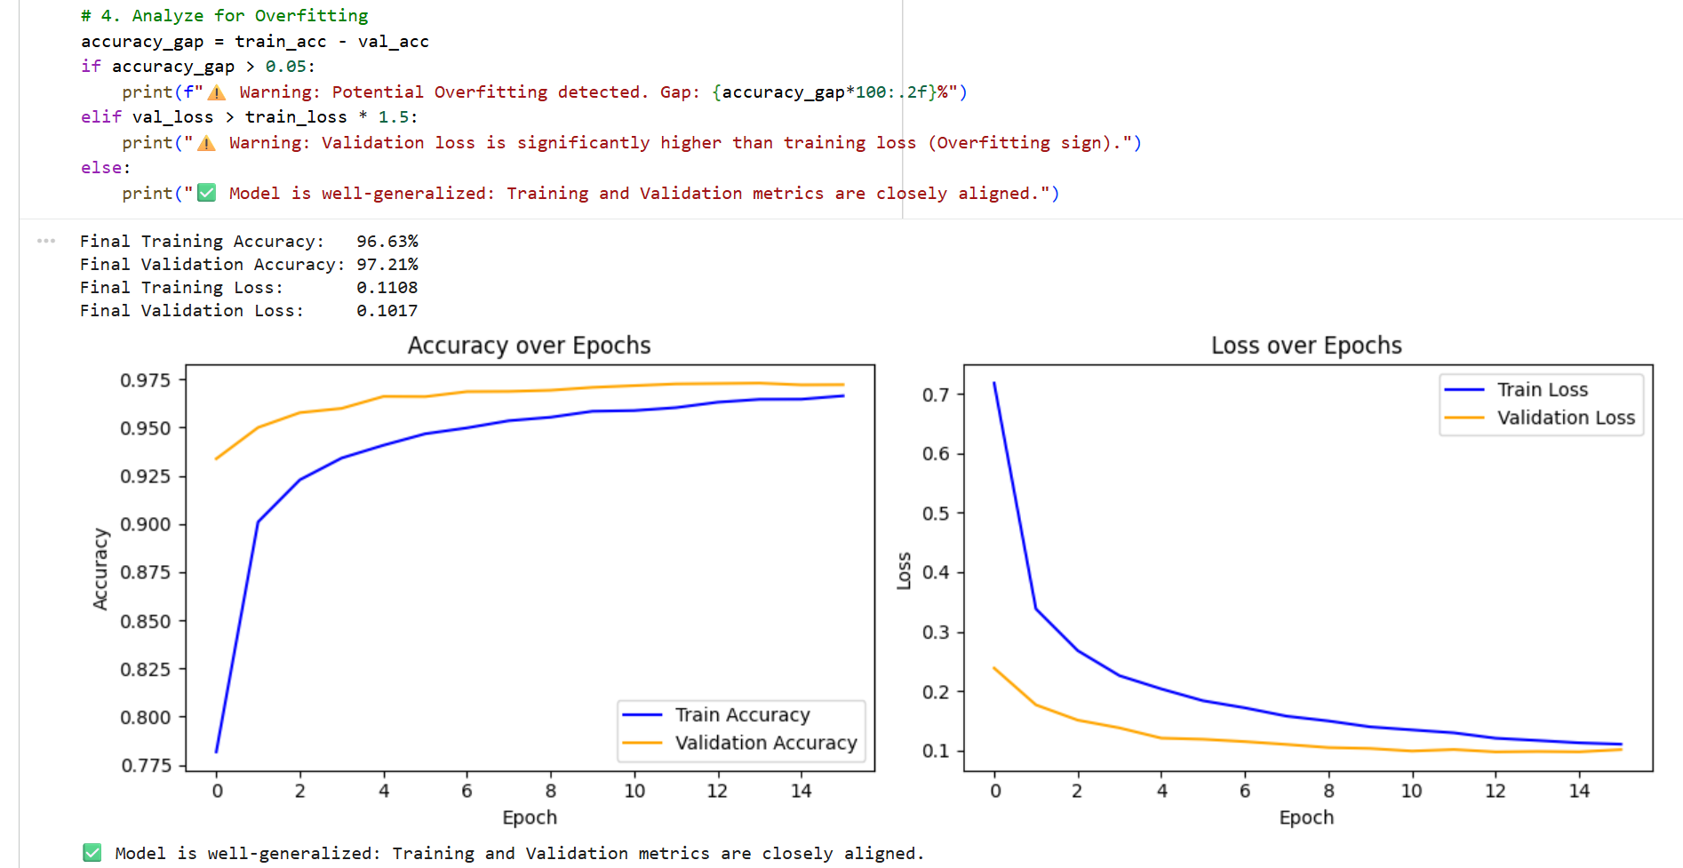
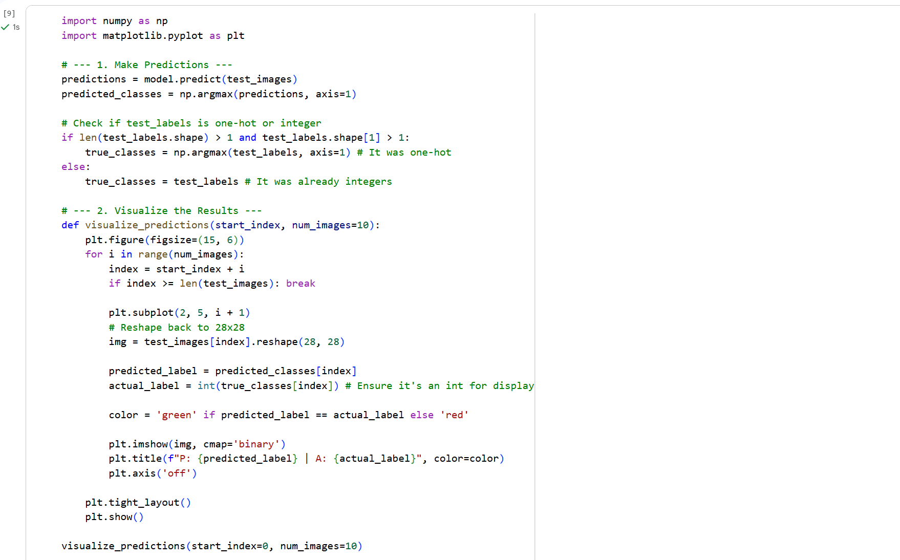

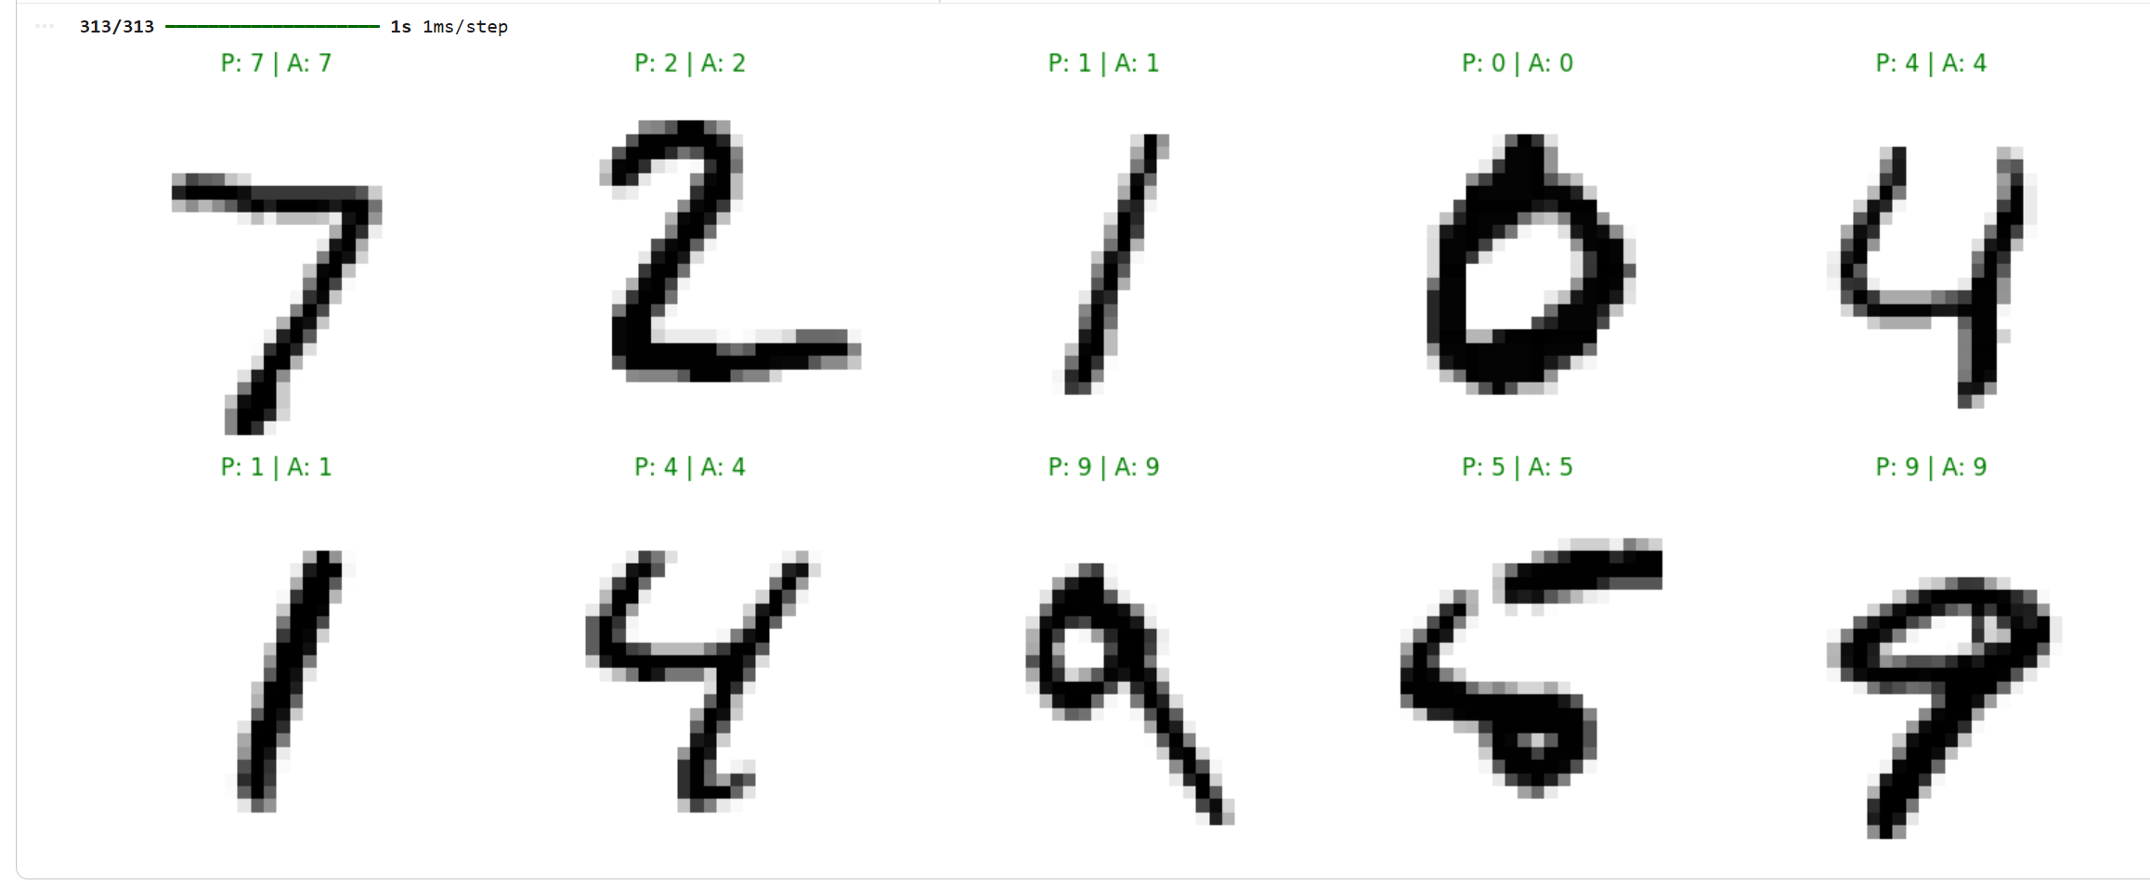

SAVING THE MODEL USING PICKLE:
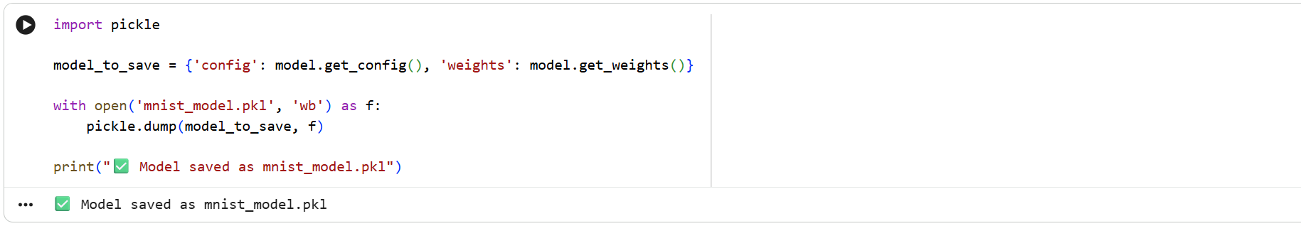

LOADING THE MODEL USING PICKLE:
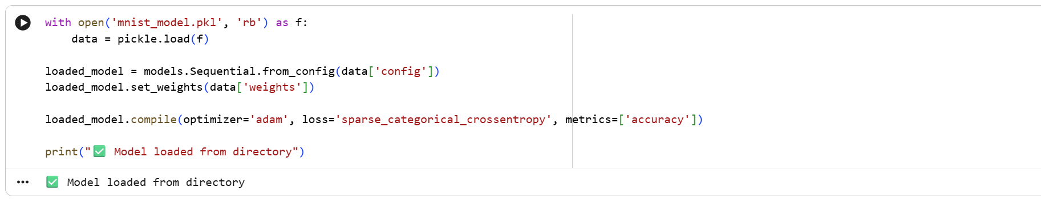

TESTING:
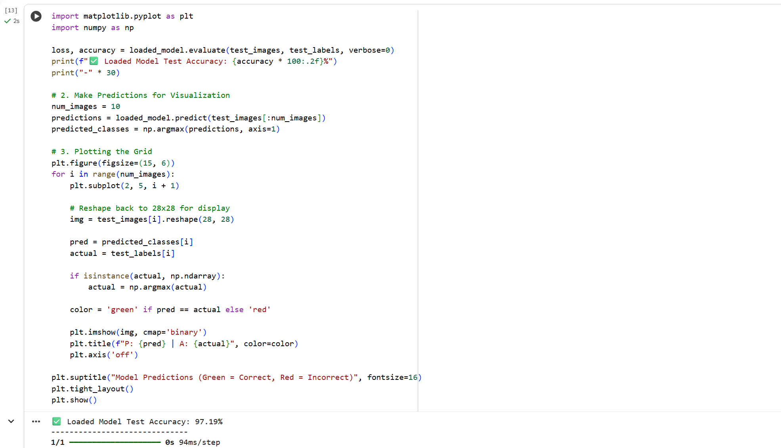
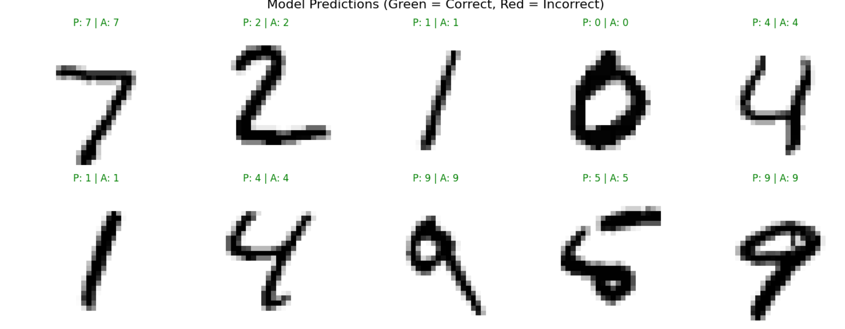

6 JARS:
1. The Data Jar
Description: This jar focuses on the collection, cleaning, and preprocessing of information. For this project, the data consists of grayscale images of handwritten digits.
Implementation:
- Loading the MNIST dataset (70,000 images).
- Normalization: Scaling pixel values from [0, 255] to [0, 1] using astype('float32') / 255.0 to help the model converge faster.
- Reshaping: Flattening 28 X 28 images into a 784-dimensional vector to suit a Dense (Fully Connected) architecture.
2. The Task Jar
Description: This defines the specific problem the machine learning system is trying to solve.
Implementation:
- Multi-class Classification: The goal is to categorize an input image into one of 10 distinct classes (the digits 0 through 9).
- This is a "Supervised Learning" task because we provide the model with labeled examples during training.
3. The Model Jar
Description: The mathematical architecture or "brain" that learns patterns from the data.
Implementation:
- Sequential Neural Network: A feed-forward architecture.
- Layers: A 64-neuron hidden layer, a 32-neuron hidden layer, and a 10-neuron output layer.
- Activations: ReLU for hidden layers to handle non-linearity and Softmax for the output layer to generate probability scores for each digit.
4. The Loss Jar
Description: The objective function that quantifies the "error" of the model's predictions compared to the actual labels.
Implementation:
- Sparse Categorical CrossEntropy: This function measures the performance of a classification model whose output is a probability value between 0 and 1.
- Edge Optimization: "Sparse" is chosen specifically to handle integer labels directly, which is more memory-efficient for edge computing than one-hot encoded labels.
5. The Learning Jar
Description: The algorithm used to update the model’s weights to minimize the loss.
Implementation:
- Optimizer: Adam (Adaptive Moment Estimation), which efficiently adjusts the learning rate during training.
- Training Loop: model.fit() with a batch size of 128 over 20 epochs.
- Regularization: Using Dropout layers and EarlyStopping to prevent overfitting, ensuring the model generalizes well to new data.
6. The Accuracy (Evaluation) Jar
Description: The metrics used to judge if the model is "good enough" for deployment.
Implementation:
- Quantitative: The accuracy metric calculated on the unseen Test Dataset.
- Qualitative: Visual verification using a grid of predictions, where green labels indicate correct classification and red indicates errors.
- Edge Readiness: Verifying the model size (e.g., ~205 KB) to ensure it fits within the memory constraints of a microcontroller.

Task-2: Data Acquisition Workflow via Edge Impulse
The following steps outline the process for collecting and preparing real-world data for edge deployment:
- Account Initialization: Create and verify an account on the Edge Impulse Studio platform. This dashboard serves as the central hub for project management, data storage, and model training.
- Project Setup: Open the Data Acquisition module within the project dashboard. This section is dedicated to capturing the raw inputs (vision, audio, or motion) required for the machine learning pipeline.
- Device Integration: Select the "Connect Data" option to link a data-source device. This allows for real-time data ingestion from hardware such as development boards, PCs, or mobile devices.
- Remote Connection: Use a smartphone to scan the provided QR code. This establishes a secure link between the phone’s camera and the Edge Impulse cloud environment.
- Data Labeling: Assign a specific Class Label (e.g., "Fan", "Light"). Accurate labeling is vital as it provides the ground truth for the model’s supervised learning process.
- Dataset Partitioning: Once collection is complete, split the images into Training and Testing sets. This ensures the model is trained on one portion of data and validated on another to check for generalization.



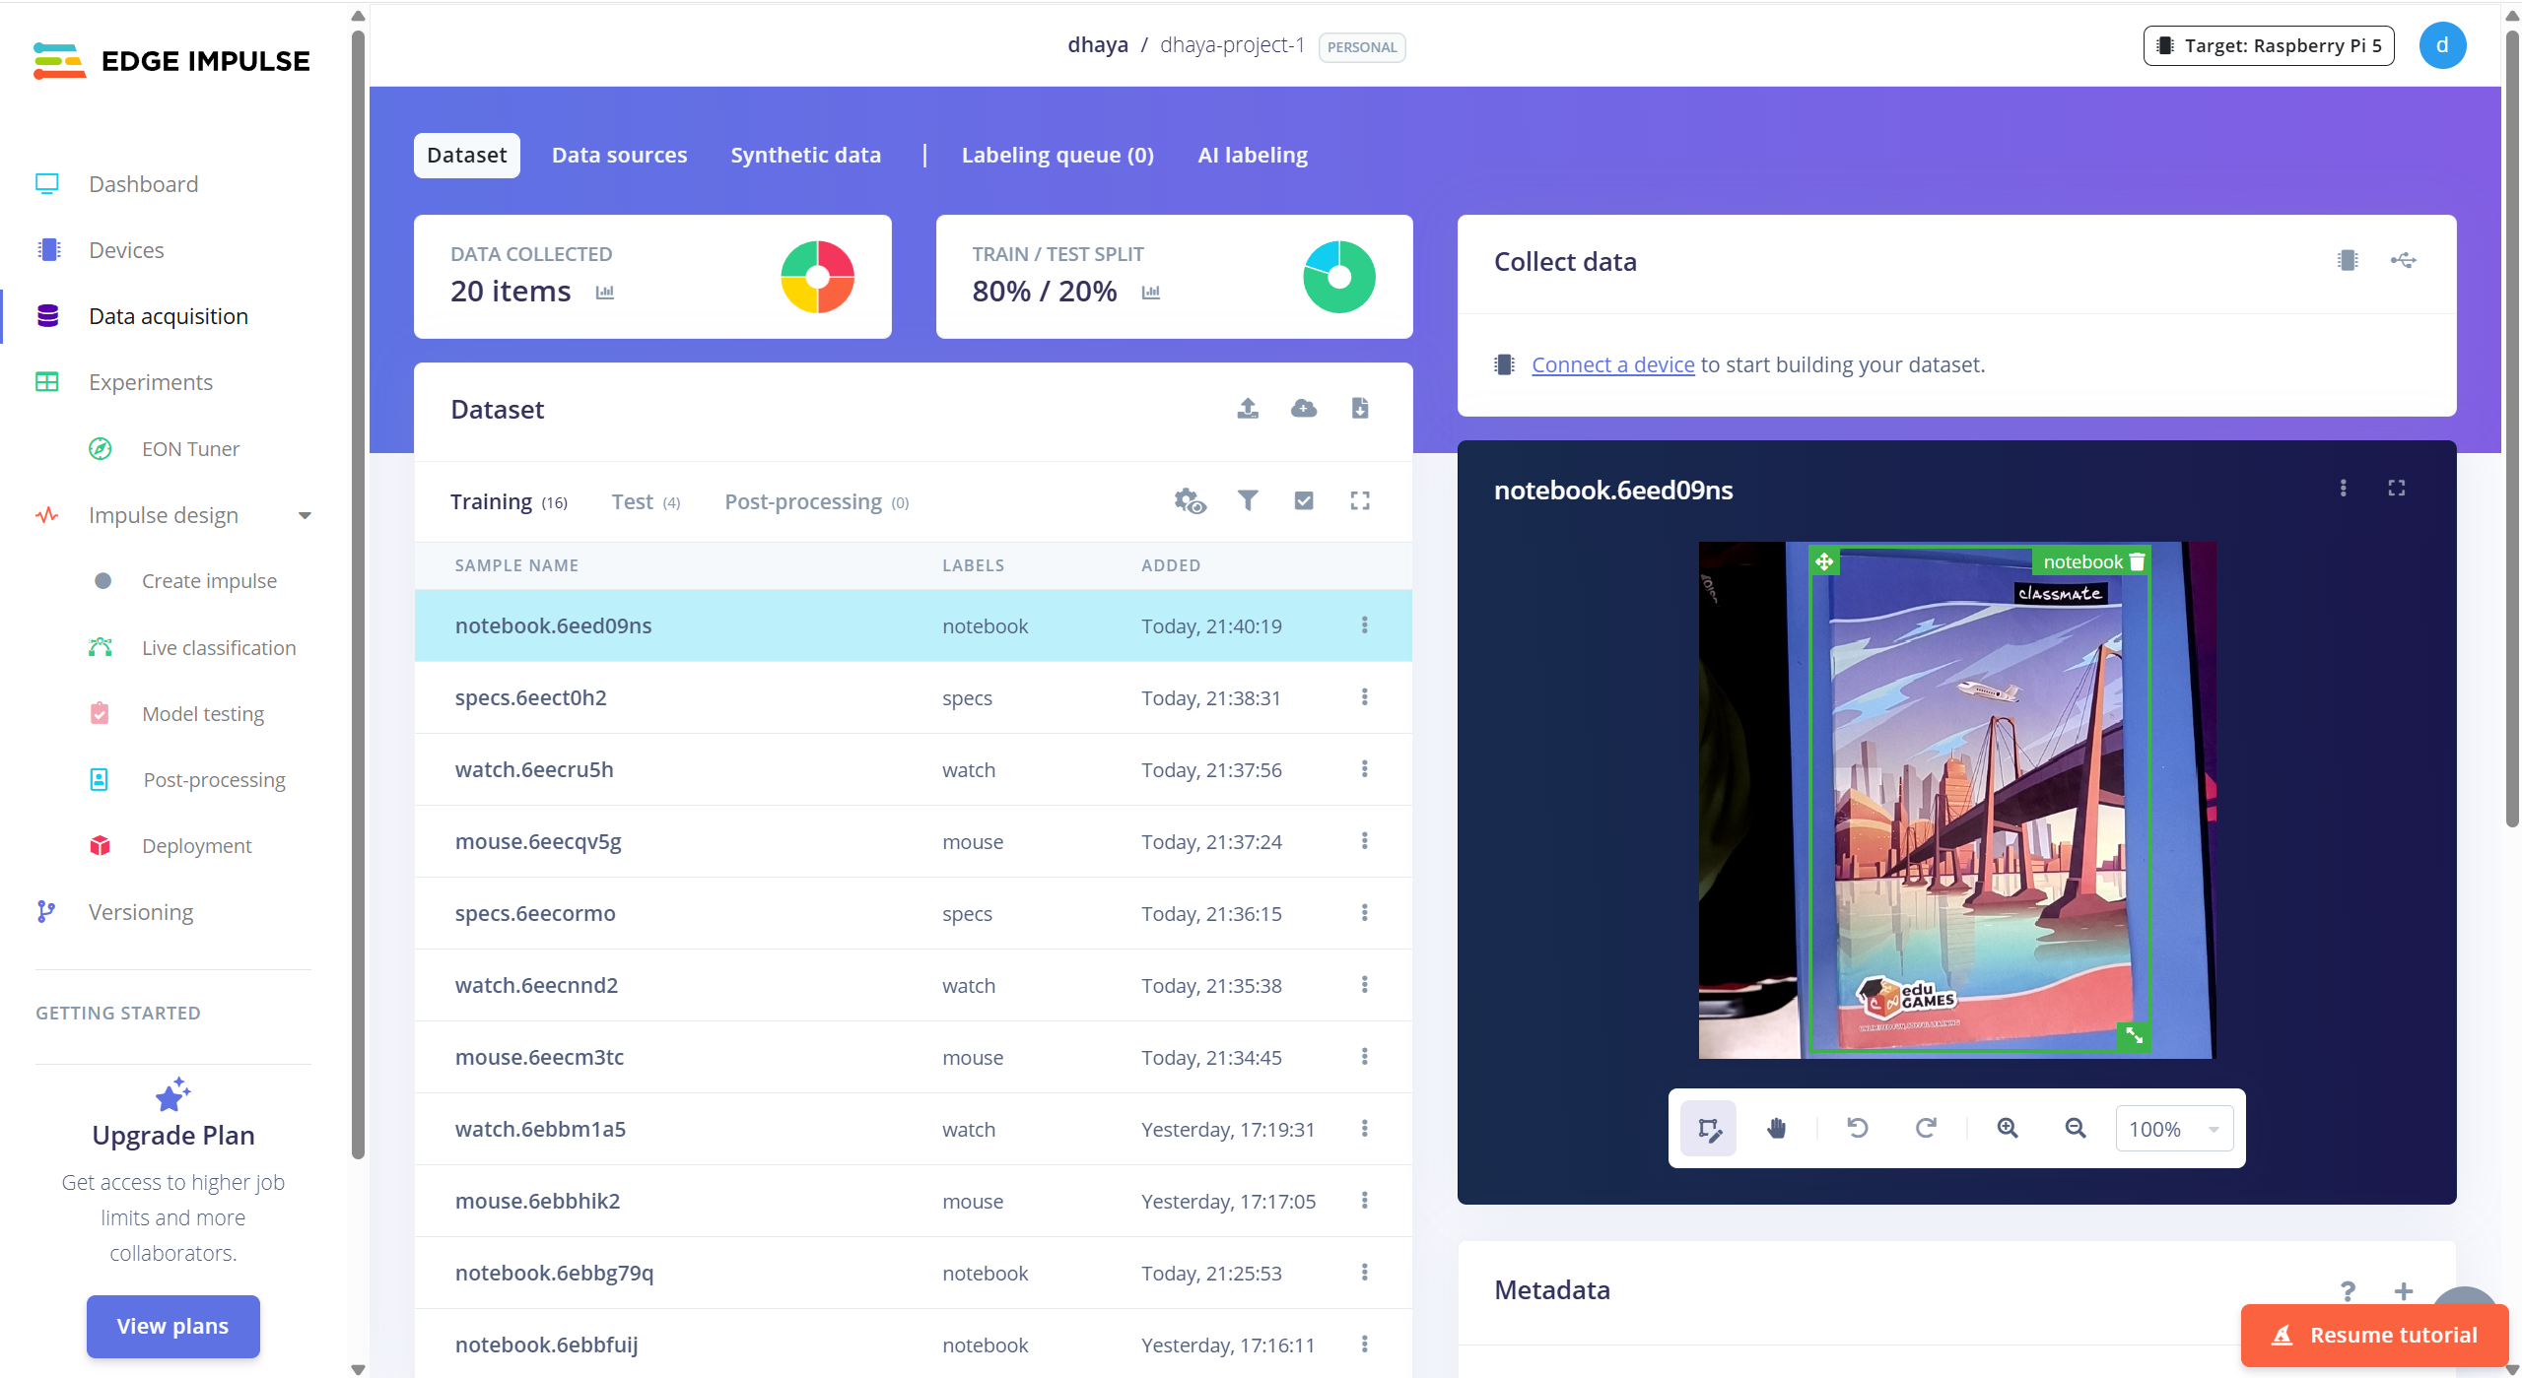

Total pictures are 20 out of which 16 are for training and 4 are for testing to get a 80:20 ratio
